Supplementary information for
Water-guided cropping: Coordinating water entitlement and crop switching to reduce irrigation and pollution-related water demand
Zhicheng Zhong ª, Haomiao Cheng ^{a*}, Yun Ge ^{b}, Xuecheng Jiang ^{c}, Zhen Qin ^{d}, Jilin Cheng ª
ª College of Hydraulic Science and Engineering, Yangzhou University, Yangzhou 225009, China
^{b} Coastal Saline-alkali Land Ecological Rehabilitation and Sustainable Utilization Technology Innovation Center, Ministry of Natural Resources, Nanjing 210007, China
^{c} College of Environmental Science and Engineering, Yangzhou University, Yangzhou 225091, China
^{d} The Eastern Route of South-to-North Water Diversion Project Jiangsu Water Source Co., Ltd. Suqian Branch, Suqian 223800, China

* Corresponding author: Prof. Dr. Haomiao Cheng
Tel: +8615295512510
Email: yzchhm@yzu.edu.cn

This file includes:
Text S1. | Calculation of WS_{green}, WD_{blue}, and WD_{grey}
Text S2. | Calculation of concentration curves and Equilibrium Index (EI)
Table S1. | Multi-year average meteorological data for 21 the water resource zones from 2002 to 2022
Table S2. | Crop agronomic, economic, and food-security parameters
Table S3. | Baseline cropping areas of the six crops across the 21 water resource zones
Table S4. | Land and irrigation parameters across the 21 water resource zones
Table S5. | Nitrogen application rates and WD_{grey} of the six crops
Table S6. | Indicator-sensitivity test for Water–Crop Suitability Pattern (W-CSP) identification under alternative criteria
Fig. S1. | Spatial clustering patterns of Relative Water Demand (RWDi) for six crops across the 21 water resource zones of Jiangsu Province.

Text S1. Calculation of WS_{green}, WD_{blue}, and WD_{grey}
Crop evapotranspiration was estimated using the CropWat 8.0 (CROPWAT Software, 2022). First, reference evapotranspiration (ET₀) was calculated using the FAO Penman–Monteith equation (Allen et al., 1998), which is recommended by the Food and Agriculture Organization (FAO), as shown in Eq. (1).
where Δ is the slope of the saturation vapor pressure curve (kPa/°C); R_{n} is the net radiation at the crop surface (MJ/m²·d¹); G is the soil heat flux (MJ/m²·d); γ is the psychrometric constant (kPa/°C); U₂ is the wind speed at 2 m above the ground (m/s); e_{s} and e_{a} are the saturation and actual vapor pressures (kPa), respectively; and T is the mean air temperature (°C).
A 10-day period (cpg) was used as the computational time step. Crop evapotranspiration (ET_{c}) for each period was then estimated by multiplying ET₀ by the crop coefficient (K_{c}), which varies with crop type and growth stage, as shown in Eq. (2).
Following the crop water accounting framework of Mekonnen et al. (2011), crop water use was separated into green and blue components. To maintain consistency with the main text and the optimization model, these components are expressed here as green water supply (WS_{green}, m³/t) and blue water demand (WD_{blue}, m³/t), both in m³/t.
WS_{green} represents the portion of crop water use supplied by soil moisture derived from effective precipitation. It was calculated based on the green component of crop evapotranspiration and crop yield, as shown in Eq. (3).
where Y is the crop yield per unit area (t/ha); 10 is the unit conversion factor transforming water depth (mm) into water volume per unit area (m³/ha); n is the number of calculation periods within the growth cycle; and ET_{green} represents the portion of crop evapotranspiration derived from effective precipitation (mm)
ET_{green} was determined from the relationship between ET_{c} and effective precipitation (P_{e}), as shown in Eqs. (4) and (5). Effective precipitation was estimated using the USDA-SCS method. Total effective precipitation during the crop growth period was obtained by summing P_{e} across all calculation periods.
WD_{blue} represents the irrigation water demand required to satisfy the portion of crop evapotranspiration not met by effective precipitation. It was calculated from the blue component of crop evapotranspiration and crop yield, as shown in Eq. (6).
where ET_{blue} represents the portion of crop evapotranspiration derived from irrigation water (mm), which was determined as shown in Eq. (7).
WD_{grey} represents the volume of water required to dilute nitrogen losses generated during crop production to meet the target water-quality standard. It was calculated as shown in Eq. (8).
where NAR is the fertilizer application per unit area (kg/ha); α is the leaching rate (the proportion of pollutants entering water bodies relative to the total chemical input); C_{max} is the maximum allowable concentration (kg/m³); and C_{nat} is the natural background concentration (kg/m³).
In this study, α was set to 10% of the nitrogen fertilizer application rate, C_{nat} was assumed to be zero, and C_{max} for nitrogen was set to 10 mg/L according to China’s Environmental Quality Standards for Surface Water. Because inter-zonal differences in these parameters were small across the study area, the same crop-specific parameter values were assigned across zones. The resulting WD_{grey} values were then incorporated into the coordinated framework as environmental input data.
References
Allen, R.G., Pereira, L.S., Raes D., Smith, M., 1998. Crop evapotranspiration-guidelines for computing crop water requirements. FAO Irrigation and Drainage Paper 56. FAO ISBN 92-5-104219-5.
CROPWAT Software, FAO, Land and Water Division (2022). Available online: http://www.fao.org/land-water/databases-and-software/cropwat/en/ (Accessed on 20 January 2022).
Mekonnen, M.M., Hoekstra, A.Y., 2011. The green, blue and grey water footprint of crops and derived crop products. Hydrology and Earth System Sciences 15 (5), 1577-1600.

Text S2. Calculation of concentration curves and Equilibrium Index (EI)
The regional irrigation supply–demand relationship was evaluated using the concentration curve and the Equilibrium Index (EI) (Gu et al., 2024). The concentration curve describes the cumulative share of irrigation demand as a function of the cumulative share of irrigation supply across sub-regions. Sub-regions were ranked according to their irrigation supply–demand distribution before plotting the curve. The line of absolute equality represents a perfectly balanced spatial distribution between irrigation supply and demand.
The Equilibrium Index (EI) was used to quantify the degree of spatial imbalance. It was calculated as twice the area between the concentration curve and the line of absolute equality, as shown in Eq. (9).
where L_{w}(p) is the concentration curve. Absolute equilibrium is represented by EI = 0, which indicates equal spatial supply-demand distribution among all sub-regions. A larger absolute value of EI indicates a stronger spatial mismatch between irrigation supply and demand. Positive and negative EI values indicate the direction of deviation from the line of absolute equality.
Reference
Gu, W., Wang, F., Siebert, S., Kummu, M., Wang, X., Hong, C., Zhou, F., Zhu, Q., Liu, Y., Qin, Y., 2024. The asymmetric impacts of international agricultural trade on water use scarcity, inequality and inequity. Nat Water 2, 324–336. https://doi.org/10.1038/s44221-024-00224-7

Table S1. Multi-year average meteorological data for 21 the water resource zones from 2002 to 2022
Zone | T_{max} (℃) | T_{min} (℃) | R_{H} (%) | U (m/s) | SD (h) | P (mm)
Z1 | 20.1 | 10.7 | 69.5 | 2.1 | 5.8 | 758
Z2 | 19.9 | 10.7 | 73.2 | 1.9 | 5.5 | 832.1
Z3 | 18.8 | 10.5 | 71.9 | 2.4 | 6.3 | 947.8
Z4 | 19.7 | 10.6 | 72.1 | 2.3 | 5.5 | 895.7
Z5 | 19.9 | 10.9 | 71.4 | 2 | 5.4 | 917
Z6 | 20.2 | 11.2 | 70.8 | 1.7 | 5.4 | 938.3
Z7 | 20.3 | 12 | 72.2 | 2.2 | 5.1 | 1100.2
Z8 | 19.4 | 10.8 | 72 | 2.4 | 5.8 | 976.4
Z9 | 19.9 | 11.1 | 72.2 | 2.5 | 5.3 | 1005
Z10 | 20.5 | 12 | 71.7 | 2.5 | 5.3 | 1106.3
Z11 | 20.5 | 12 | 74.1 | 2.6 | 5.6 | 1167.8
Z12 | 21.1 | 13 | 71.2 | 2.6 | 5.2 | 1207.6
Z13 | 20.5 | 12.8 | 70.9 | 2.5 | 5.8 | 1107
Z14 | 20.7 | 12.6 | 76 | 2.5 | 5.4 | 1153.7
Z15 | 21.3 | 13.3 | 74.3 | 2 | 5.1 | 1208.8
Z16 | 21.4 | 13.5 | 73.1 | 2.3 | 5.1 | 1209
Z17 | 20.8 | 12.9 | 76.7 | 2.8 | 5.3 | 1212
Z18 | 20.1 | 12.4 | 77 | 3 | 5.5 | 1132.5
Z19 | 21.1 | 13.3 | 74.3 | 2.7 | 5.2 | 1210.7
Z20 | 21.4 | 13.6 | 71.8 | 2.6 | 5.1 | 1209.3
Z21 | 21.1 | 13.8 | 74.3 | 2.8 | 5.1 | 1241.6
Note. T_{max}: maximum temperatures; T_{min}: minimum temperatures; R_{H}: relative humidity; U: wind speed measured at the height of 2 m; SD: sunshine duration; P: precipitation.

Table S2. Crop agronomic, economic, and food-security parameters
Crop | Y_{j,max} (ton/ha) | Growth stage duration | K_{j} | P_{j}  (CNY/ton) | C_{j}  (CNY/ton) | MD_{j}  (10⁵ ton)
Rice | 8.92 | 18 Jun. - 20 Sep. | 1.10 | 2720 | 2180 | 127.13
Maize | 6.05 | 11 Jun. - 15 Sep. | 1.25 | 1770 | 1420 | 25.43
Peanut | 4.08 | 15 Jun. - 18 Oct. | 0.70 | 5630 | 4500 | 4.64
Cotton | 1.27 | 01 Jun. - 31 Oct. | 0.85 | 18160 | 14530 | 1.06
Wheat | 5.70 | 16 Oct. - 03 Jun. | 1.10 | 2230 | 1780 | 101.70
Rapeseed | 2.96 | 21 Nov. - 21 May. | 0.92 | 4510 | 3640 | 9.28
Note. Y_{j,max}: maximum yield; K_{j}: yield response factor; P_{j}: selling price; C_{j}: production cost; MD_{j}: minimum local demand.

Table S3. Baseline cropping areas of the six crops across the 21 water resource zones
Zone | Baseline cropping area (S_{ij}, ha)
 | Rice | Maize | Peanut | Cotton | Wheat | Rapeseed
Z1 | 75507 | 80492 | 9894 | 0 | 165035 | 858
Z2 | 78117 | 80492 | 9894 | 0 | 165035 | 858
Z3 | 38171 | 29178 | 12601 | 0 | 164690 | 1203
Z4 | 218258 | 39441 | 12060 | 0 | 164759 | 1134
Z5 | 207624 | 32184 | 8116 | 7 | 164578 | 1315
Z6 | 105546 | 49572 | 6709 | 7 | 164516 | 1211
Z7 | 20578 | 10888 | 2550 | 8 | 159349 | 6544
Z8 | 8335 | 20189 | 2443 | 22 | 155393 | 10500
Z9 | 97603 | 7270 | 1853 | 5 | 155494 | 10399
Z10 | 316919 | 7974 | 2326 | 7 | 148725 | 17168
Z11 | 85519 | 29490 | 2335 | 36 | 151437 | 14456
Z12 | 125143 | 30313 | 4279 | 82 | 147563 | 18330
Z13 | 71725 | 5847 | 1018 | 189 | 131346 | 34547
Z14 | 47902 | 10888 | 1567 | 227 | 118346 | 47547
Z15 | 43962 | 9852 | 1229 | 378 | 112981 | 52912
Z16 | 8511 | 6573 | 415 | 0 | 129825 | 36068
Z17 | 72718 | 4854 | 6878 | 0 | 143051 | 22842
Z18 | 47315 | 33601 | 12053 | 267 | 132067 | 33826
Z19 | 749 | 1032 | 0 | 18 | 153781 | 12112
Z20 | 681 | 2063 | 0 | 36 | 156014 | 9879
Z21 | 6 | 2063 | 0 | 36 | 156014 | 9879

Table S4. Land and irrigation parameters across the 21 water resource zones
Zone | Total farmland area (A_{i}, ha) | Irrigation utilization efficiency (n_{i})
Z1 | 165893 | 0.62
Z2 | 171627 | 0.60
Z3 | 51020 | 0.61
Z4 | 316520 | 0.57
Z5 | 274260 | 0.58
Z6 | 159993 | 0.61
Z7 | 22393 | 0.58
Z8 | 9653 | 0.59
Z9 | 103286 | 0.58
Z10 | 337915 | 0.63
Z11 | 105848 | 0.60
Z12 | 158211 | 0.61
Z13 | 74910 | 0.64
Z14 | 51867 | 0.62
Z15 | 47224 | 0.62
Z16 | 8885 | 0.64
Z17 | 78252 | 0.62
Z18 | 65426 | 0.61
Z19 | 754 | 0.65
Z20 | 690 | 0.65
Z21 | 6 | 0.67

Table S5. Nitrogen application rates and WD_{grey} of the six crops
Crop | Nitrogen application rates (ton/ha) | WD_{grey}  (m³/t)
Rice | 6.6 | 111
Maize | 4.1 | 101
Peanut | 1.0 | 37
Cotton | 1.6 | 150
Wheat | 4.8 | 126
Rapeseed | 1.7 | 84

Table S6. Indicator-sensitivity test for Water–Crop Suitability Pattern (W-CSP) identification under alternative criteria
Identification criterion | Rice | Maize | Peanut | Cotton | Wheat | Rapeseed
RWD_{i}-only criterion | Z2, Z3, Z4, Z5, Z6, Z7, Z8, Z9, Z10, Z11, Z14 | Z1, Z2, Z3, Z4, Z5, Z6, Z7, Z8, Z9, Z10, Z11 | Z1, Z2, Z3, Z4, Z5, Z6, Z7, Z8, Z9, Z10, Z11, Z14 | Z1, Z2, Z3, Z4, Z5, Z6, Z7, Z8, Z9, Z10, Z11, Z14 | Z10, Z11, Z12, Z14, Z15, Z16, Z17, Z18, Z19, Z20, Z21 | Z11, Z12, Z14, Z15, Z16, Z17, Z18, Z19, Z20, Z21
RWD_{i}–CSC_{i} criterion | Z4, Z5 | / | Z6, Z7, Z10, Z11, | Z4, Z5, Z6, Z7, Z8, Z9, Z10, Z11, Z14 | Z10, Z11, Z12, Z14, Z16, Z17, Z18, Z19, Z20 | Z11, Z12, Z14, Z16, Z18, Z19, Z20
W-CSP criterion | Z4, Z5 | / | Z6, Z7, Z10, Z11 | Z5, Z6, Z7, Z10, Z11 | Z11, Z14, Z16, Z18, Z19, Z20 | Z11, Z12, Z14, Z18, Z19, Z20
Note. The RWD_{i}-only criterion identifies zones with below-average irrigation demand, i.e., RWD_{i}<0. The RWD_{i}–CSC_{i} criterion further requires CSC_{i} <-0.4, indicating a negative precipitation–irrigation relationship. The final W-CSP criterion additionally requires statistical significance at p<0.05. “/” indicates that no zone satisfies the corresponding criterion.

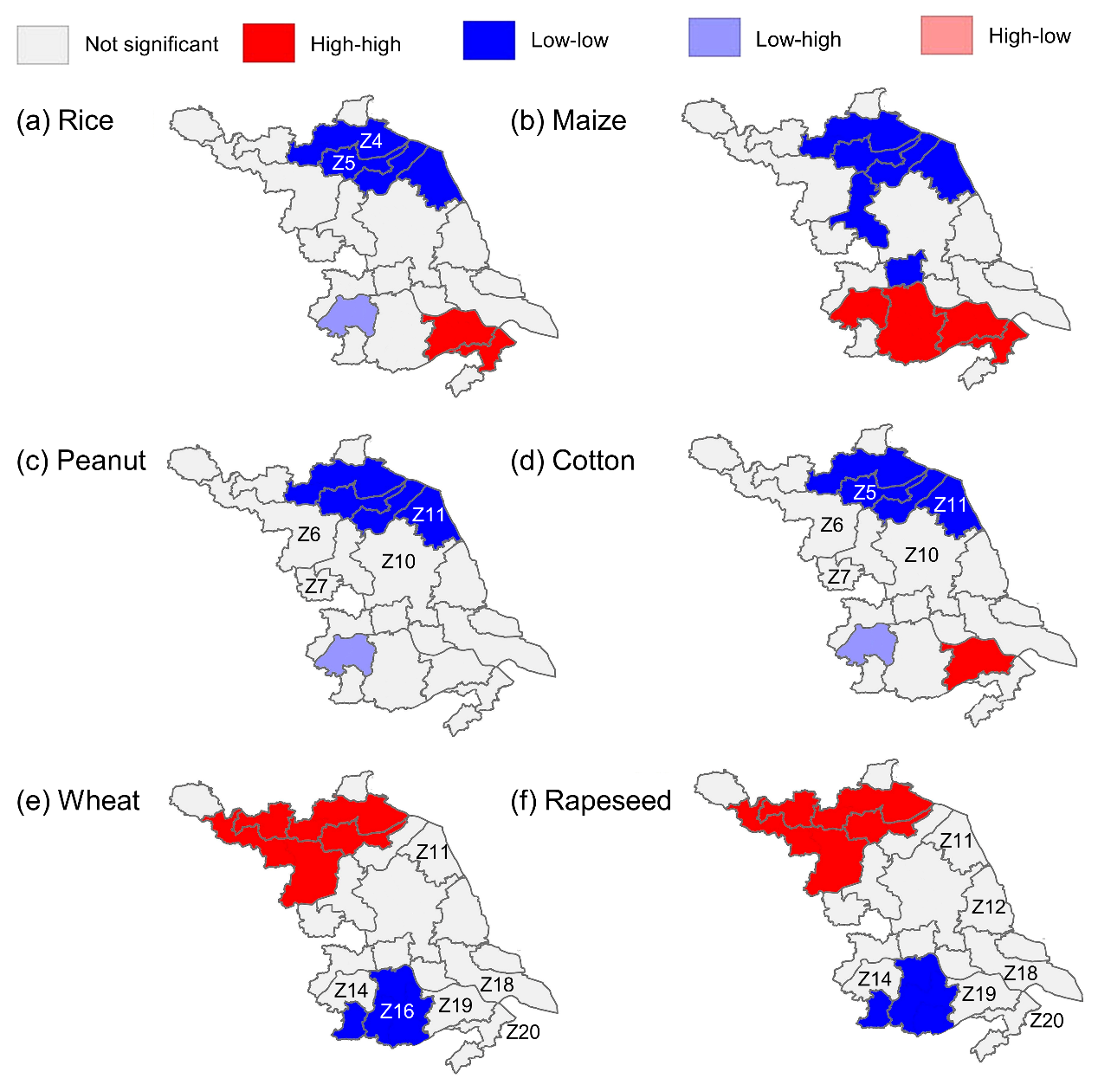
Fig. S1. Spatial clustering patterns of Relative Water Demand (RWD_{i}) for six crops across the 21 water resource zones of Jiangsu Province. High–high and low–low clusters indicate zones where relatively high or low irrigation demand is spatially aggregated, respectively, while other categories indicate spatial outliers or non-significant clustering.

